**Daniel Williamson**

**Project #3**

**9/26/16**

**CS 212**

[**http://cefns.nau.edu/~daw277/index.html**](http://cefns.nau.edu/~daw277/index.html)

Disclaimer:

Tested only on Google Chrome.

Also, resume page link can be found in the footer.

Project Overview

Purpose:

The purpose of this project was to explore CSS with HTML. We will use CSS to make our website appear better. Giving it images and links for useful navigation. Basically use CSS to establish a general ‘look and feel’ for our websites. Also, we will be creating a page for a resume, which is optional.

Approach:

To begin this project, I reviewed our notes from class and reviewed w3schools for help on dealing with the purposes of this project. I then began by creating a style sheet for my website. I immediately noticed that there are a ton of things you can do to make your site look amazing. I decided to go with something simple. Nothing to over the top. I had already created my navbar from the previous project to I just snuck that into the header. Afterwards, I began working on my resume page and creating an entirely new/separate style sheet from my index. Once completed I went back and started going down your list of things that need to be implemented. I added a sidebar that is absolutely positioned so that it stays with you while you scroll. I implemented a notification tray that is also absolutely positioned. It does not have any functionality to it right now. Anyway, the site looks great and here are my results!

Results

**DISCALMAIR,** I did all my testing in Chrome, I understand it kind of looks bad on other sites. I did not have time to fix this.

These are my results:

This is my header, it contains the navbar and banner photo.

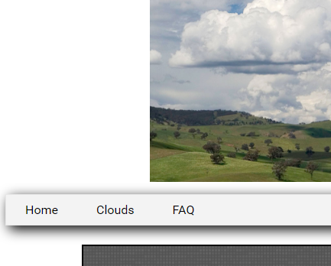

This is my footer, it contains the link to my resume page.



This is the main body/layout.

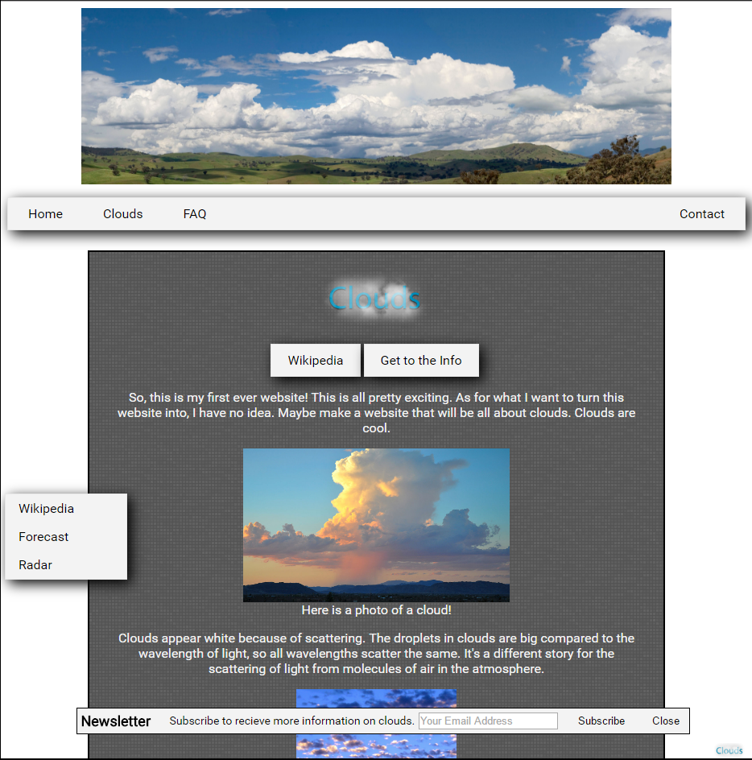

This is my absolute positioned sidebar. That also overlays some elements.

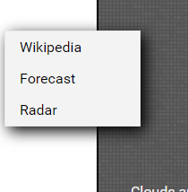

This is my absolute positined sidebar. Also overlays elements.

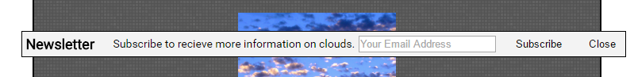

Another absolute positioned element, found in the buttom right. Very tiny.



This is a photo of the background. I wanted to point out that it is not just black or gray. It is infact an image on repeat. Which is behind all other elements.

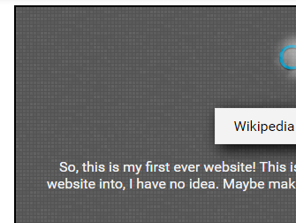

This is an image of my resume with a different style sheet. The link to this can be found in the footer.

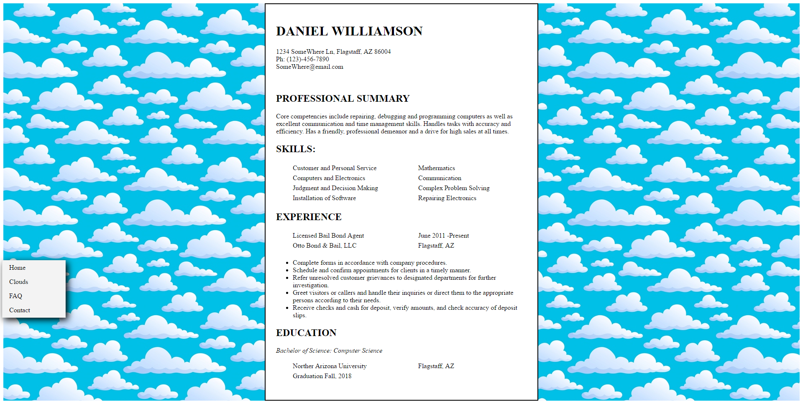

I added this photo, because it was my understanding from Pat, that I needed to have a div within a div. I just wanted to show you an example I had.

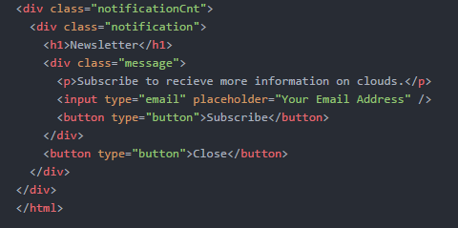

Testing:

As for testing, pretty much everything works. All links will lead you to the correct page.

Conclusion

In conclusion this was a rather fun project. I learned a lot about HTML and how it works. I’m really excited about learning more about it and how to manipulate it into doing what I want to do. I really want to learn how to make the NavBar float with you while you scroll past it. I imagine that uses javascript and perhaps I’ll get to try it in later project. W3schools was a big help, along with some peers giving me pointers on what looks good and what doesn’t. All in all, fun project and I’m looking forward to more.